Rhubarb Performance Commission
Wakefield Exchange (WX) is an event and exhibition space in the heart of Wakefield, operated by Wakefield Council. The former market hall has been transformed into a venue that aims to offer accessible and inclusive entertainment, creativity and culture for the people of our district and beyond.
Find out more about the venue and our programme here: Welcome to Wakefield Exchange
About the opportunity
During February Half Term 2027, WX will be celebrating Wakefield's unique heritage as part of the famous Rhubarb Triangle. Alongside the annual Wakefield Rhubarb Festival, we will be welcoming visitors throughout the half term week.
We are seeking to commission three performers to deliver family-friendly performances during half term and the festival itself. Whether you are a storyteller, musician, comedian, magician, poet or theatre-maker we are interested to hear from you.
We're looking for work that will delight children and families, create memorable moments, and bring energy and excitement to the festival atmosphere. We welcome bold, imaginative and eccentric proposals. Your performance might draw inspiration from rhubarb growing traditions, local folklore, Wakefield's heritage, cookery themes, or simply embrace the fun and community spirit of the Rhubarb Festival. This does not need to be brand new work, but can be adapted existing work.
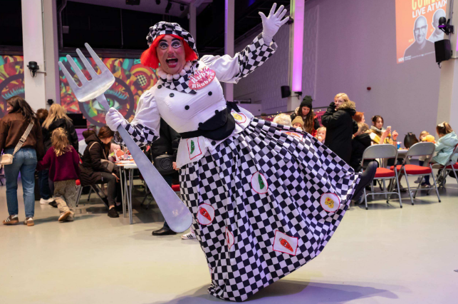
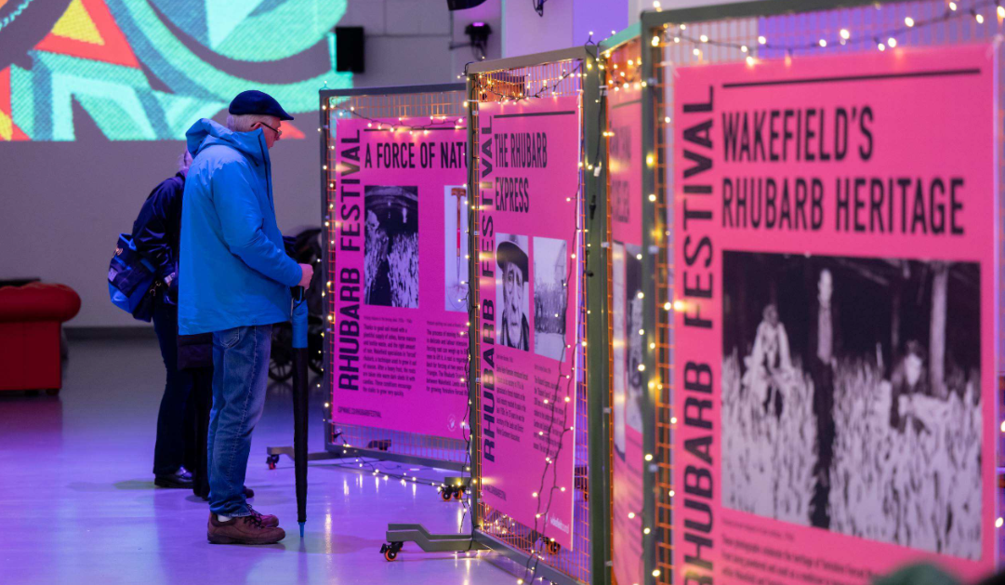

Particulars
- Each performance should be approximately 30 mins long (maximum 45 mins)
- You will perform 5 times - 1 performance for 5 consecutive days - see dates and times below.
- The performance will take place on stage at the far end of our main hall (The Shed)
- The stage is 3.6m deep by 4.8m wide
- Basic audio equipment is available, such as handheld mics, headset mics, cables and PA system
- We do not have any props but chairs & tables can be provided
- For each performance you will have half an hour to set up and pack down before and after the set (allowing for changeover between performances)
- There is no curtain or enclosure around the stage so please note you will be visible to the public during set up
- A private changing area can be provided if needed
Please note: There may be a lot of background noise/chatter during the performance, particularly during Rhubarb Festival as this is a very popular event, and WX gets very busy with visitors. There will be additional activities occurring simultaneously, such as drop in crafts and face painting (details TBC).
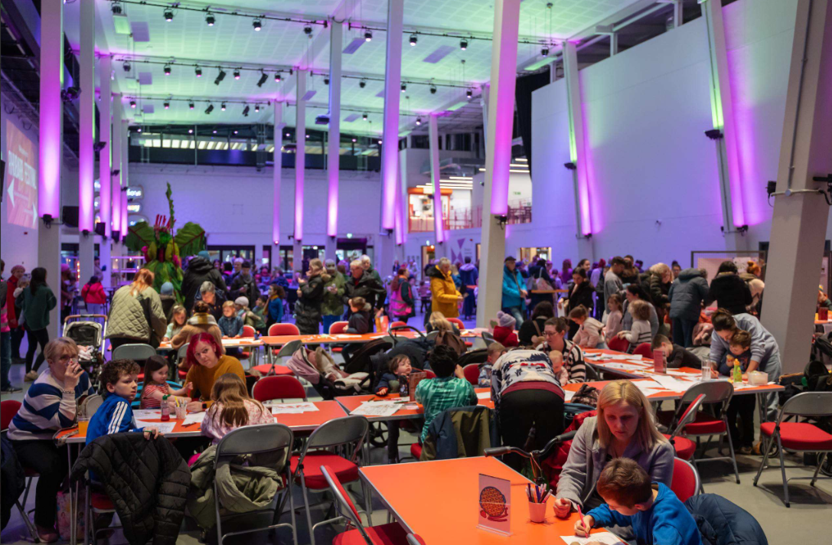
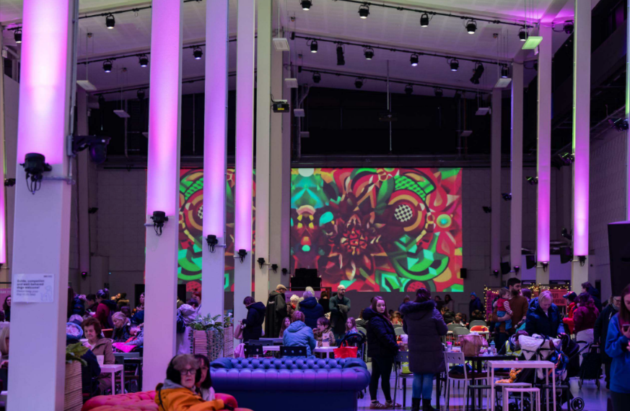

Date and time
Dates: February 2027
- Tuesday 16th
- Wednesday 17th
- (other activity is taking place on Thursday)
- Friday 19th
- Sat 20th
- Sun 21st
Time slots – these will be allocated to you should you be successful, therefore at the point of application you should be available for any of the times
- 11am each day – approx. 30 to 45 minutes OR
- 1pm each day – approx. 30 to 45 minutes OR
- 3pm each day – approx. 30 to 45 minutes

Fee
A fixed commission fee of £1500 exclusive of VAT is available, including development and delivery. An additional £100 is also available for props as needed. Our usual payment schedule is 50% upfront, with the remainder on delivery – other arrangements can be made if needed.
Please specify your fee in your application.

What will we be looking for?
The selected artists will need to have:
- Proven experience delivering engaging performances for public audiences
- A friendly, welcoming and inclusive approach
- Confidence in performing for children and family audiences
- Experience adapting to busy public environments and varying audience sizes
- Public Liability Insurance (£5 million)
- The ability to provide a risk assessment where appropriate
We are particularly interested in proposals that:
- Celebrate Wakefield's connection to the Rhubarb Triangle
- Spark imagination and curiosity in children and families
- Respond creatively to local history, folklore or community stories
- Are accessible to drop-in audiences throughout the festival and half term period

How to apply
Please email hello@wxwakefield.co.uk including:
- A brief description of your performance idea (max 200 words)
- A brief description of your experience (max 200 words)
- Images/videos of previous relevant work
- Your fee, including time, materials & travel
- Your tech requirements based on the above particulars we are able to provide
- An equalities monitoring form which can be downloaded alongside this information sheet on our website. Please note, this is optional, but helps us ensure our commissioning practices are inclusive.

Please note applications will be assessed on experience, relevance to brief, concept creativity and value for money. Preference may be given to artists living and/or working in the Wakefield District. Please do specify your location in your application.

Want to apply in another way?
We welcome applications in written, audio and video format. If you have any concerns or queries about accessibility, please contact hello@wxwakefield.co.uk

Deadline: Midnight, Sun 18th Oct
- Programming Assessment Panel to review all applications in that week
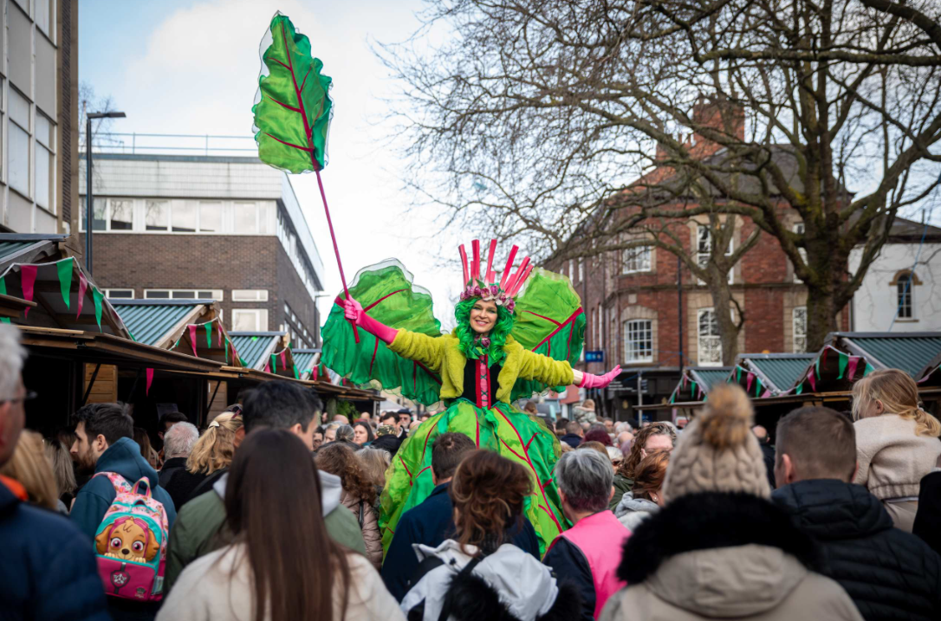
- We aim to provide outcomes by Friday 23rd October

